Austin Stephens

Assignment 06

3/4/17

1. My program successfully searches through the larger string for smaller keywords and tells the user if the keywords are found in the string.

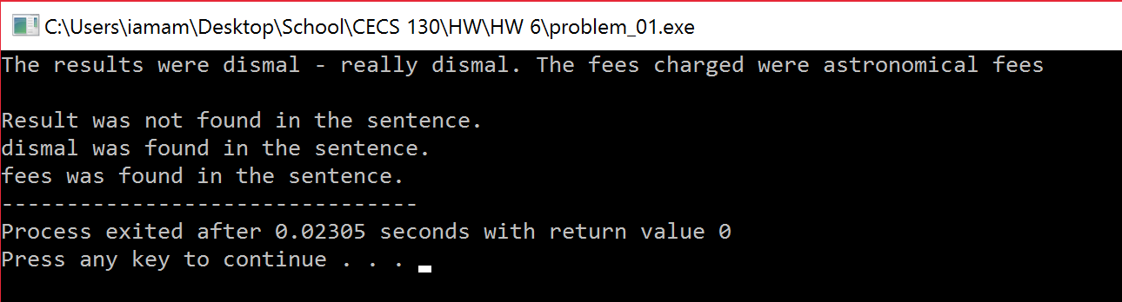

1. My program successfully declares and initializes a string array with the words given and then uses a function findMin() to compare the array and print the smallest string based on ASCII values.

